SBC AWS Landing Zone Project

# Update Stack for VPC Provisioning

**Version 1.0 Date: 22-August-2022**

Table of Contents

Update Stack for VPC Provisioning 1

Table of Contents 1

1 Overview 2

2 Prerequisite(s) 2

3 Steps under Service Catalog Account 2

Overview

This document describes how to update Stack for VPC Provisioning.

1. Prerequisite(s)

Prerequisites are that the VPC stack should already exist.

1. Steps under Service Catalog Account
   1. Login to the AWS Service Catalog delegated Administrator account.

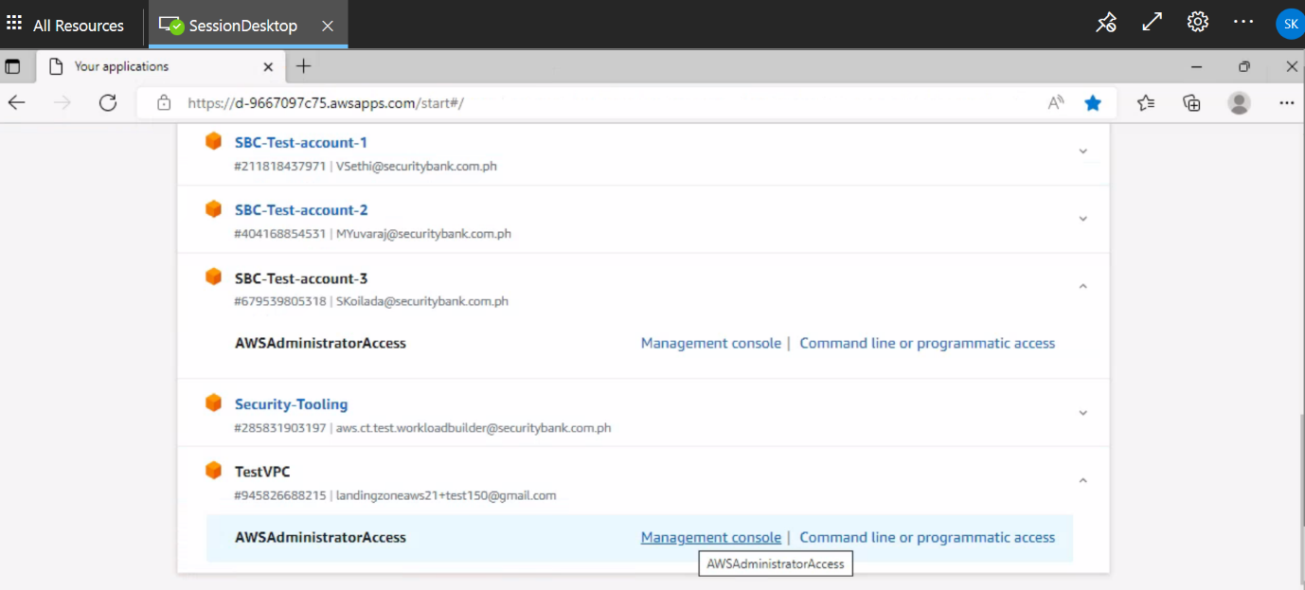

* 1. Navigate to **Service Catalog** -> **Portfolios** and select the VPC Portfolio.

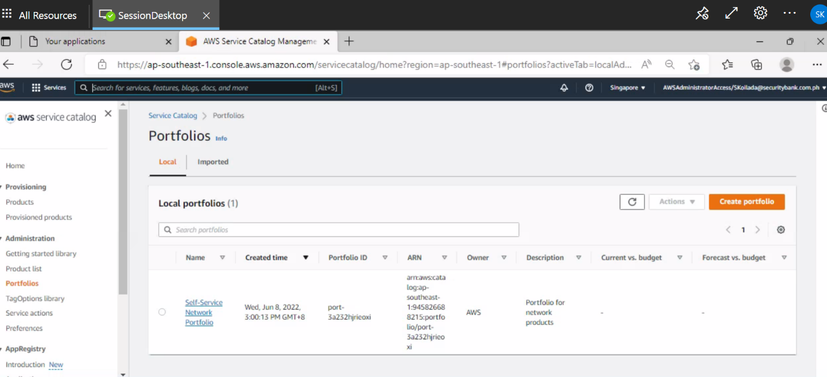

* 1. Select the Member Account Id and click on **Unshare**.

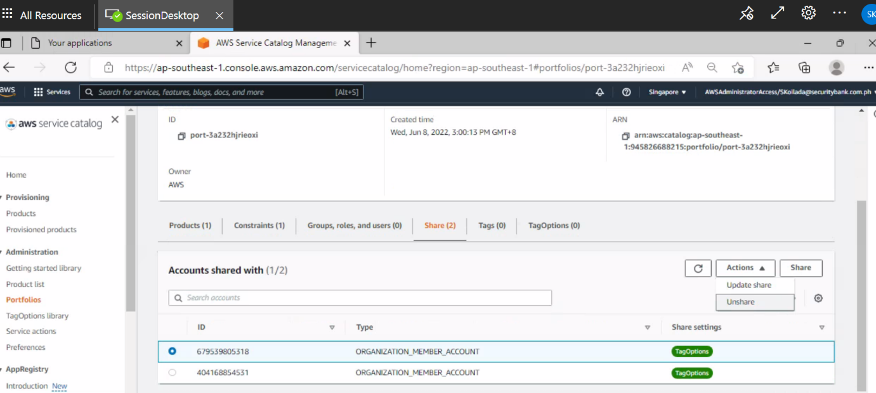

* 1. Navigate to S3 service and upload the required VPC files to existing bucket named “**sbc-vpc-provisioning**” and copy the Object URL.

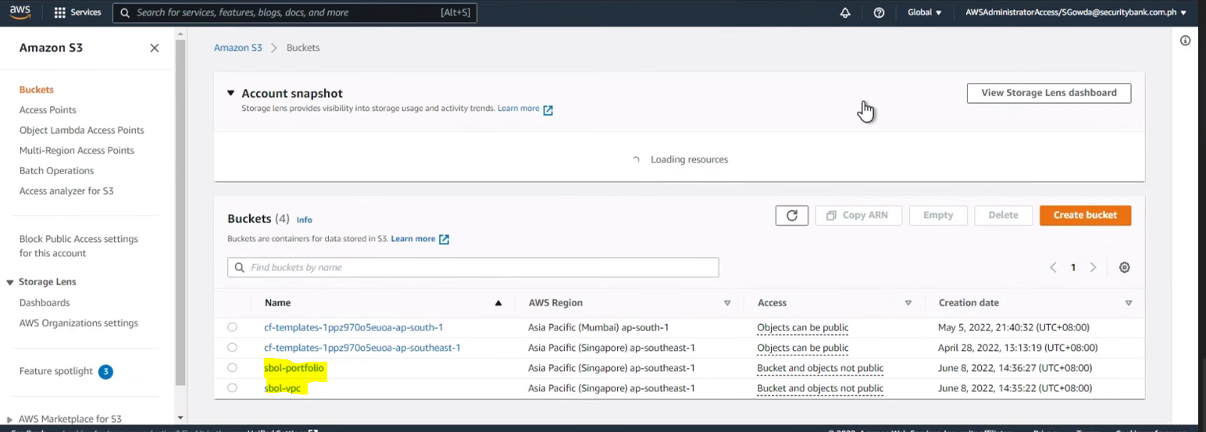

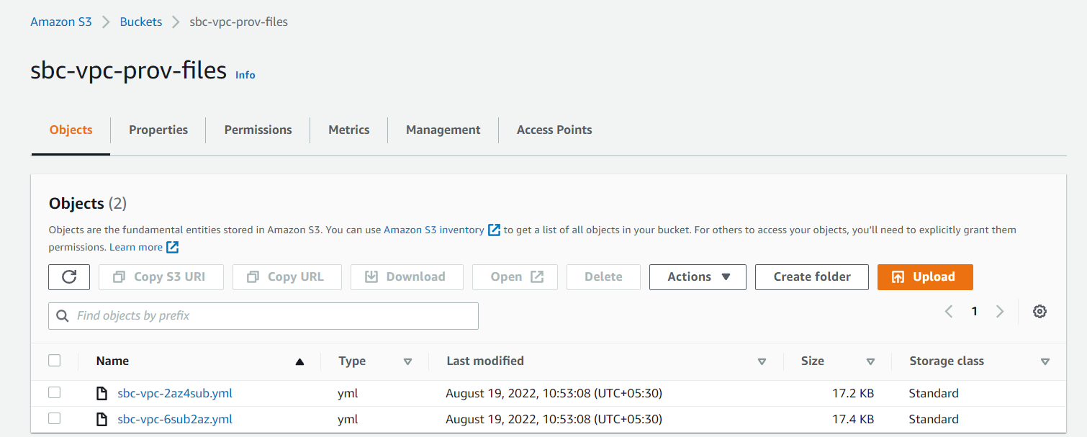

* 1. Navigate to Cloud Formation Service, select the VPC stack and click on **Update Stack**.

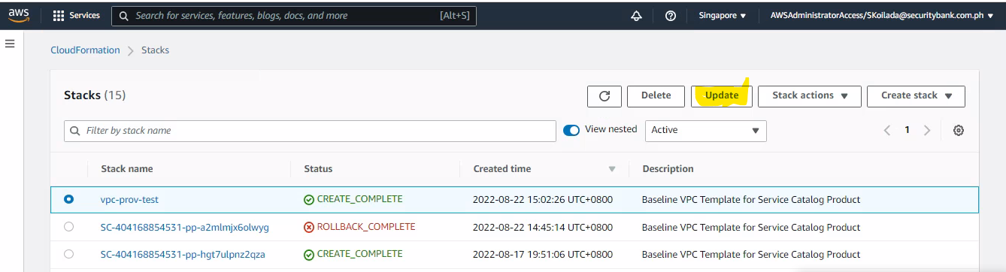

* 1. Select **Replace Current Template** and paste the object URL(refer to 3.4) of the required VPC file.

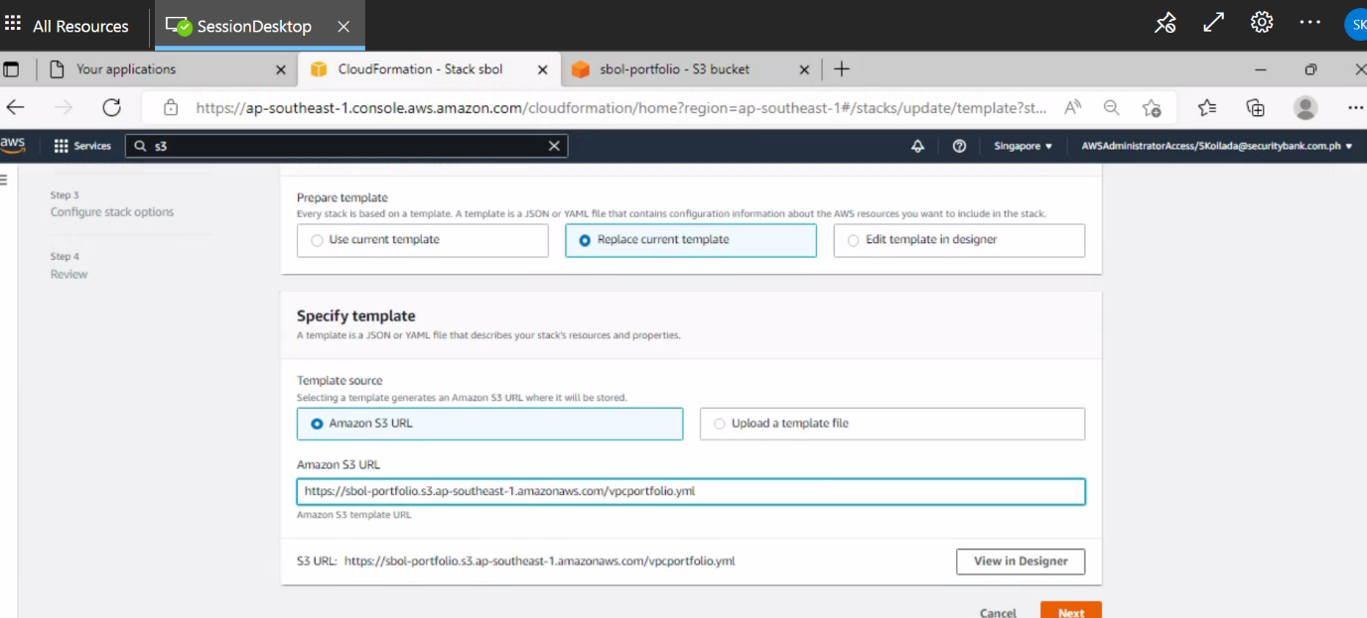

* 1. Specify the stack details and click on **Next** -> **Next** -> **Update Stack.**

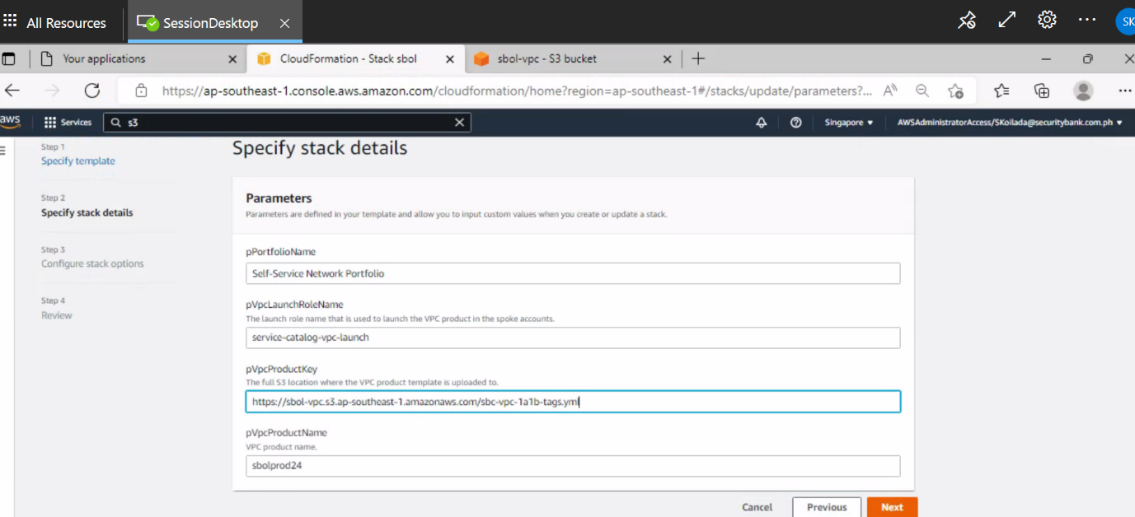

* 1. You can see that the stack is updated successfully.

